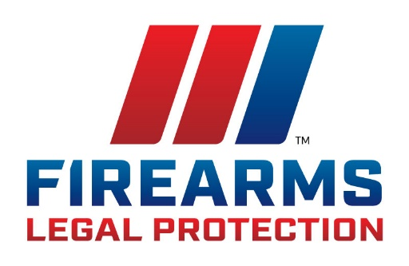
FOR IMMEDIATE RELEASE

Iowa Firearms Coalition Partners
with Firearms Legal Protection
(Moville, Iowa) Firearms Legal Protection, a provider of pre-paid legal defense memberships for self-defense, will be listed as a preferred partner of Iowa Firearms Coalition (IFC) for Iowa residents looking to arrange pre-paid self-defense legal protection.
On February 4th, IFC John McLaughlin announced that Texas-based Firearms Legal Protection has been chosen to offer prepaid self-defense benefits to the thousands of IFC members in Iowa. “Firearms Legal Protection shares our vision of protecting and defending the Second Amendment and helping sane, sober, prudent, moral people from all walks of life win the fight after the fight,” says McLaughlin. “Unlike other plans we looked at, FLP pays uncapped attorney fees directly in criminal and civil cases. Our members will not be handicapped by having to pay their defense out of pocket while waiting for reimbursement. Another huge benefit of this partnership is coverage for expert witnesses, investigators, lost wages during trial, scene clean up, and even coordination of counseling services,” note McLaughlin.
IFC President Dave Funk adds, “In today’s political climate, you can do everything right in a self-defense case and still go to jail and lose every penny. The Iowa Firearms Coalition cares deeply about our members and their families. Removing the financial burden of obtaining a qualified, vetted defense team to represent them in their darkest hour deserves careful consideration.”
“We value IFC’s commitment to standing up for the second amendment rights of every Iowan, and every American,” said Firearm’s Legal Protection Director or Marketing, Pliny Gale. “We are happy to provide a special rate on legal protection plans to members of IFC.”
About Iowa Firearms Coalition
A true grassroots organization made up of thousands of gun owners throughout the state, Iowa Firearms Coalition is the preeminent organization defending Second Amendment rights in Iowa. Our members are absolutely committed to preserving these rights and IFC’s leaders work tirelessly and without pay on behalf of our membership in that fight. IFC traces its roots back to 2005 when four Iowans decided the state’s draconian “May Issue” Permit to Carry system was unfairly discriminating against many of Iowa’s gun owners and formed and action-oriented group called “Iowa Carry”. Iowa Carry was the prime mover in getting our present “Shall Issue” law enacted. The group changed the name to “Iowa Firearms Coalition” and has grown drastically while leading the fight for gun the rights of Iowa gun owners on a variety of legislative issues.
About Firearms Legal Protection
Firearms Legal Protection provides uncapped legal defense coverage for its members who legally use a firearm (or any legal weapon) in self-defense, or the defense of others. Unfortunately, when people use a firearm in self-defense they could get arrested, put in jail, and face extensive legal costs. Firearms Legal Protection provides members with peace of mind in these difficult situations by providing uncapped attorney fees, and other benefits such a bail bond protection. Firearms Legal protection operates a 24-hour attorney answered emergency hotline for members. All Firearms Legal Protection members receive benefits including legal protection against Red Flag laws, webinars, product discounts, and more. Protect yourself. We’ll Protect you.
Media Contact
Pliny Gale
Director of Marketing
pgale@firearmslegal.com
www.firearmslegal.com

